1. Agenda:
   1. Producer configuration via java code with bean instead of application.yml
2. 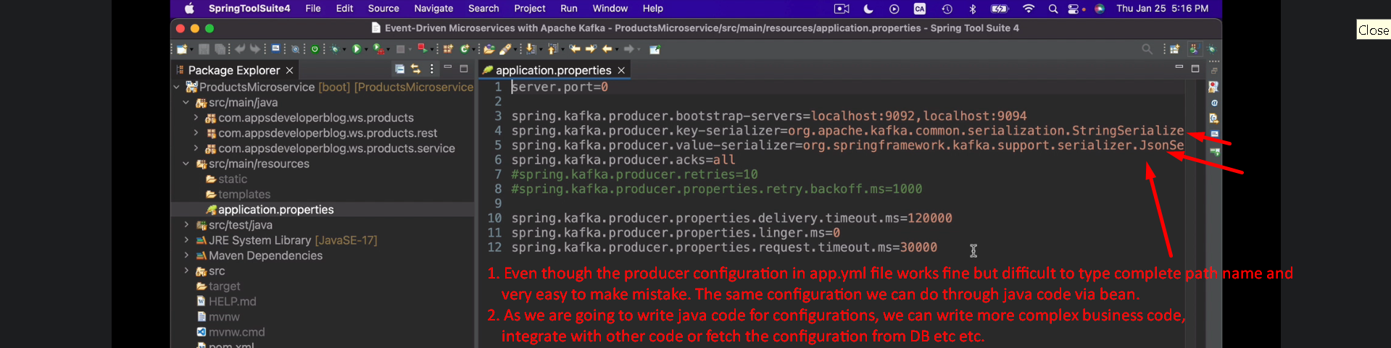
3. 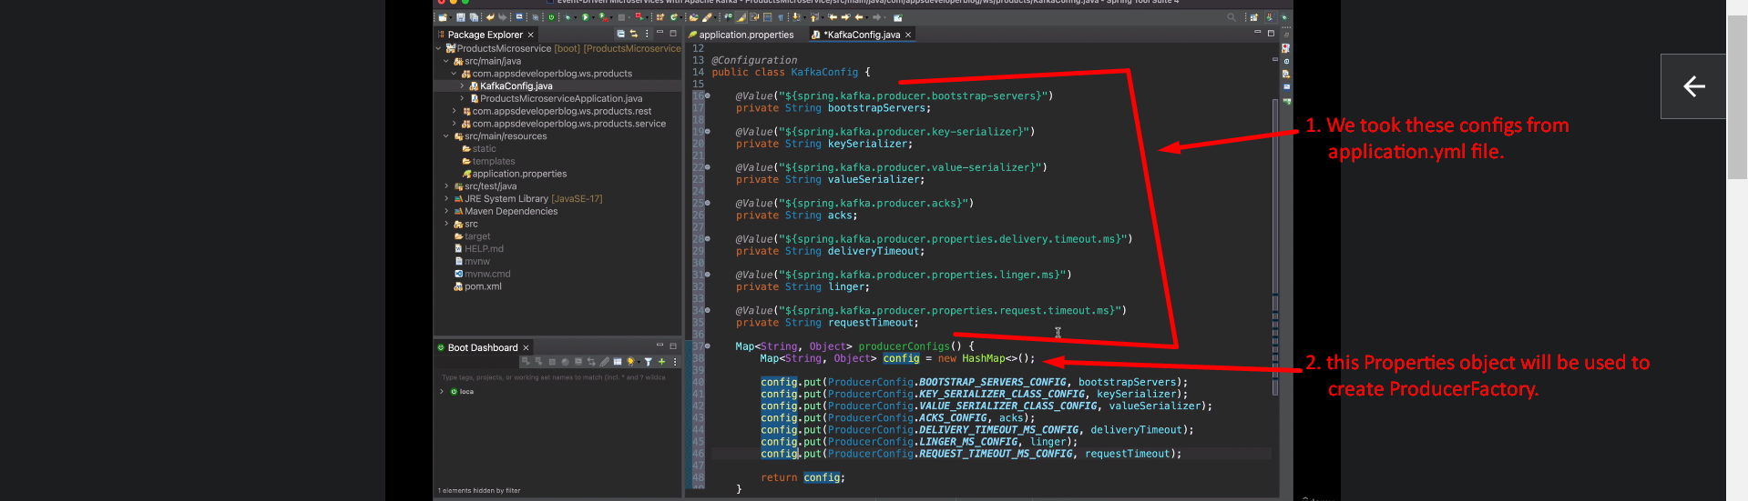
4. 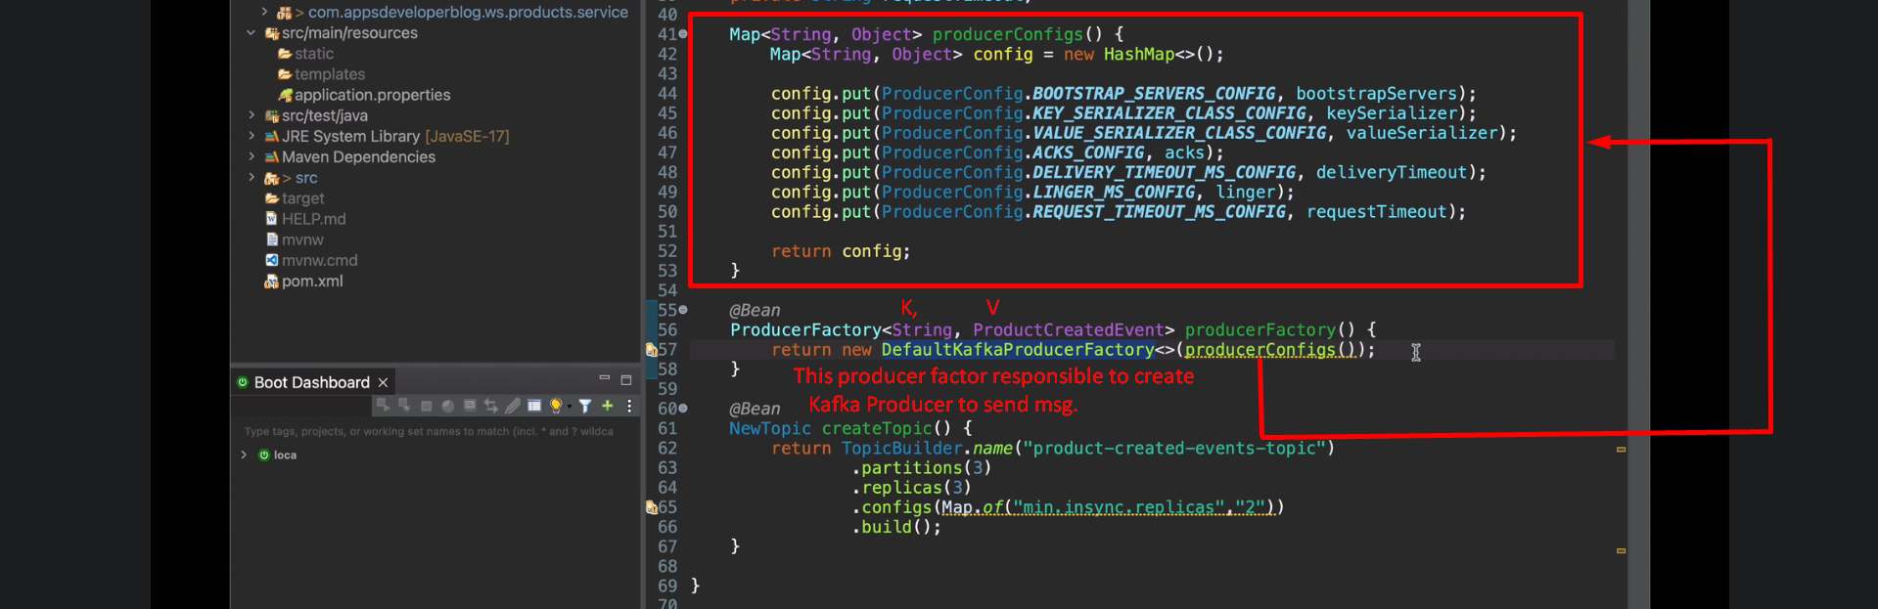
5. 